Dashboard Design

Date | 20- September 2026
Team ID | MCA
Project Name | Smartphone Usage & Digital Addiction and Well-Being Analytics
Maximum Marks | 5 marks

Creating an effective dashboard for Smartphone Usage & Digital Addiction and Well-Being Analytics involves presenting smartphone usage patterns, digital addiction levels, and well-being indicators in a clear and interactive format. The dashboard helps users understand screen-time patterns and their relationship with sleep, stress, physical activity, and overall well-being.

Activity 1: Interactive and visually appealing dashboards
Creating an interactive and visually appealing dashboard for smartphone usage and digital addiction involves the effective use of charts, KPIs, filters, and interactive features. The dashboard should provide users with a simple way to analyze smartphone usage patterns and understand their impact on digital well-being.
Clear and Intuitive Layout
Arrange KPI cards, charts, graphs, and filters in a simple layout so that smartphone usage and well-being information can be easily understood.
Use Appropriate Visualizations
Use bar charts, pie charts, line charts, and KPI cards to display screen time, smartphone usage frequency, digital addiction levels, sleep duration, stress levels, and well-being scores.
Colour and Theming
Use a consistent colour theme to differentiate low, moderate, and high levels of smartphone usage and digital addiction.
Interactive Filters and Slicers
Provide filters and slicers for age group, gender, occupation, daily screen time, addiction level, and well-being category.
Drill-Down Capabilities
Allow users to explore overall smartphone usage and drill down into specific age groups, genders, or addiction levels for detailed analysis.
Responsive Design
Design the dashboard so that all charts, KPI cards, filters, and other visual elements are clearly visible and easy to understand.
Custom Visuals and Icons
Use suitable icons for smartphone usage, screen time, sleep, stress, physical activity, and digital well-being.
Use of Infographics
Use infographic-style KPI cards and visual indicators to present important smartphone usage and well-being statistics in an easy-to-understand format.
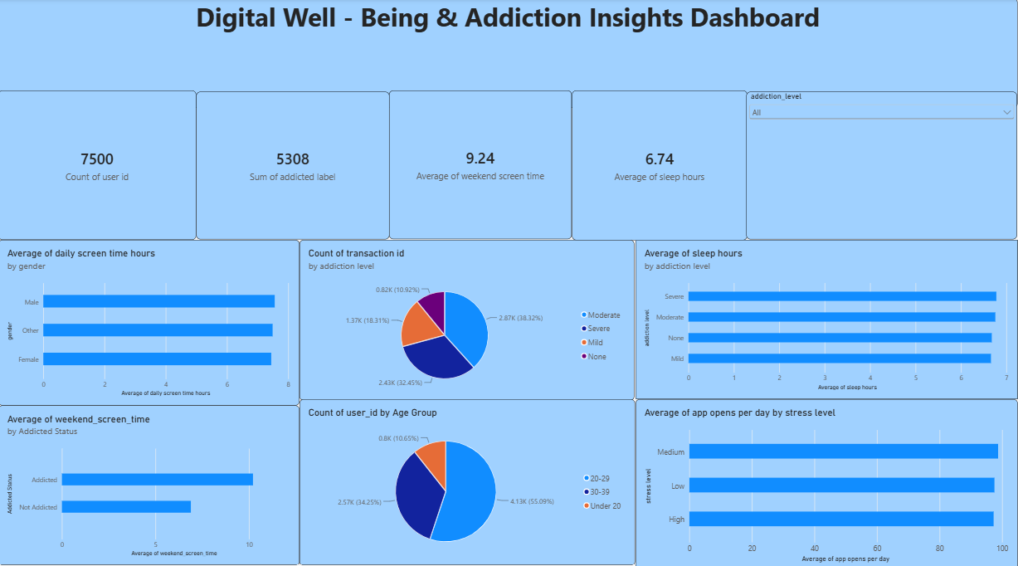

Note: Highlight the major outcomes in form of bullet points
Sample:
Here are five potential outcomes from the dashboard image provided:
Major Outcomes from the Dashboard
- Total Users: The dashboard displays the total number of users included in the smartphone usage and well-being dataset.
- Average Screen Time: The dashboard identifies the average daily smartphone screen time and helps understand overall usage patterns.
- Digital Addiction Levels: Users are categorized into low, moderate, and high digital addiction levels based on their smartphone usage patterns.
- Age-wise Smartphone Usage: The dashboard compares smartphone usage across different age groups to identify groups with higher usage.
- Sleep and Screen Time: The dashboard helps analyze the relationship between smartphone screen time and users' sleep duration.
- Stress and Digital Addiction: The dashboard highlights patterns between digital addiction levels and reported stress levels.
- Overall Well-Being: The dashboard provides an overall view of users' well-being based on smartphone usage, sleep, stress, and physical activity indicators.

